CREATING AN INSTAGRAM REEL FOR BUSINESS PROMOTION

**TEAM NAME:** TECH SLAVES

**TEAM MEMBERS:** THIRUAZHAGAN.K.T-au420720105057,THIRUNAVUKKARASU.D-au420720105058, KALAIVANAN.R-420720105017, ARJUN.A-au420720105008.

**BRAND NAME:** FRAME FUSSION

**CATEGORY**: CLOTH BRAND

**TARGET AUDIENCE:** ALL (MEN, WOMEN,KIDS)

**EMAIL:** [framefussion1@gmail.com](mailto:framefussion1@gmail.com)

**INSTAGRAM BUSINESS PAGE:** <https://instagram.com/framefussion2023?igshid=MzNlNGNkZWQ4Mg==>

**DOCUMENTATION:**

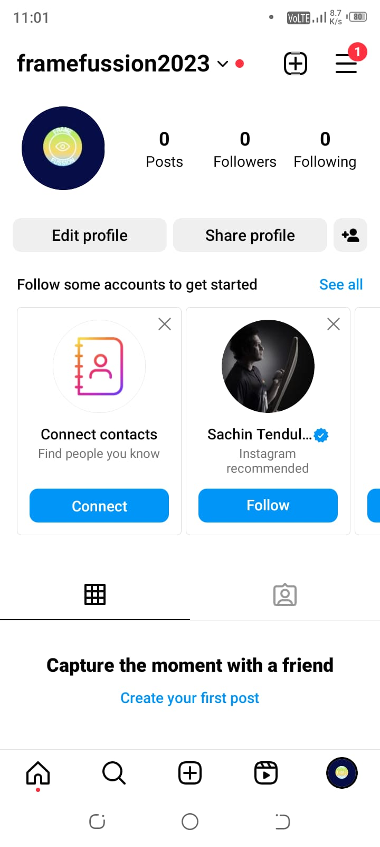

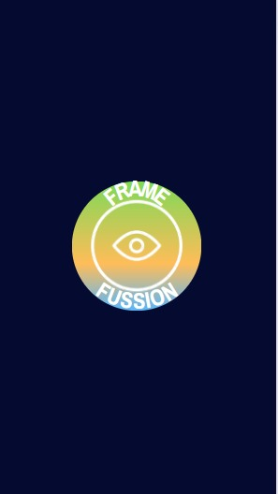

**INSTAGRAM PAGE**

**BRAND LOGO**

**CREATING INSTAGRAM REEL USING CANVA(SCREENSHOTS)**

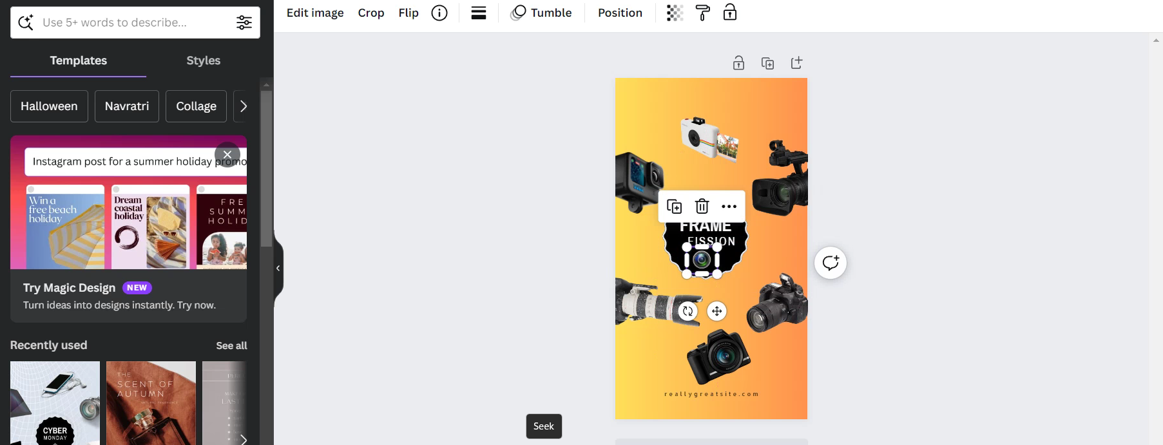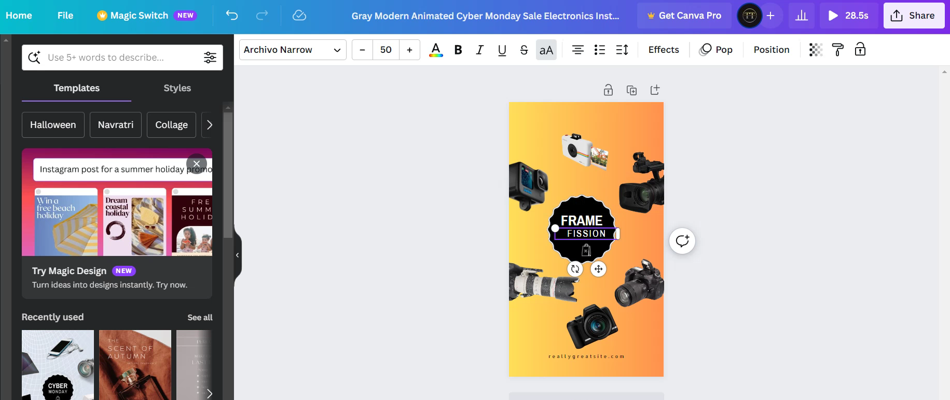

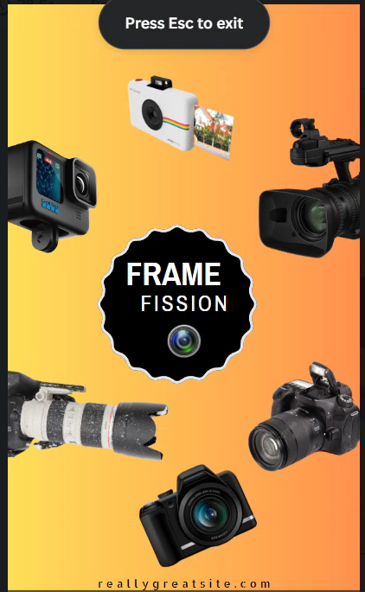

**FIRST SLIDE**

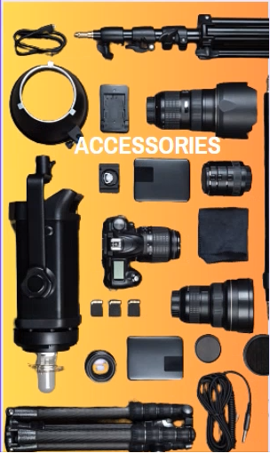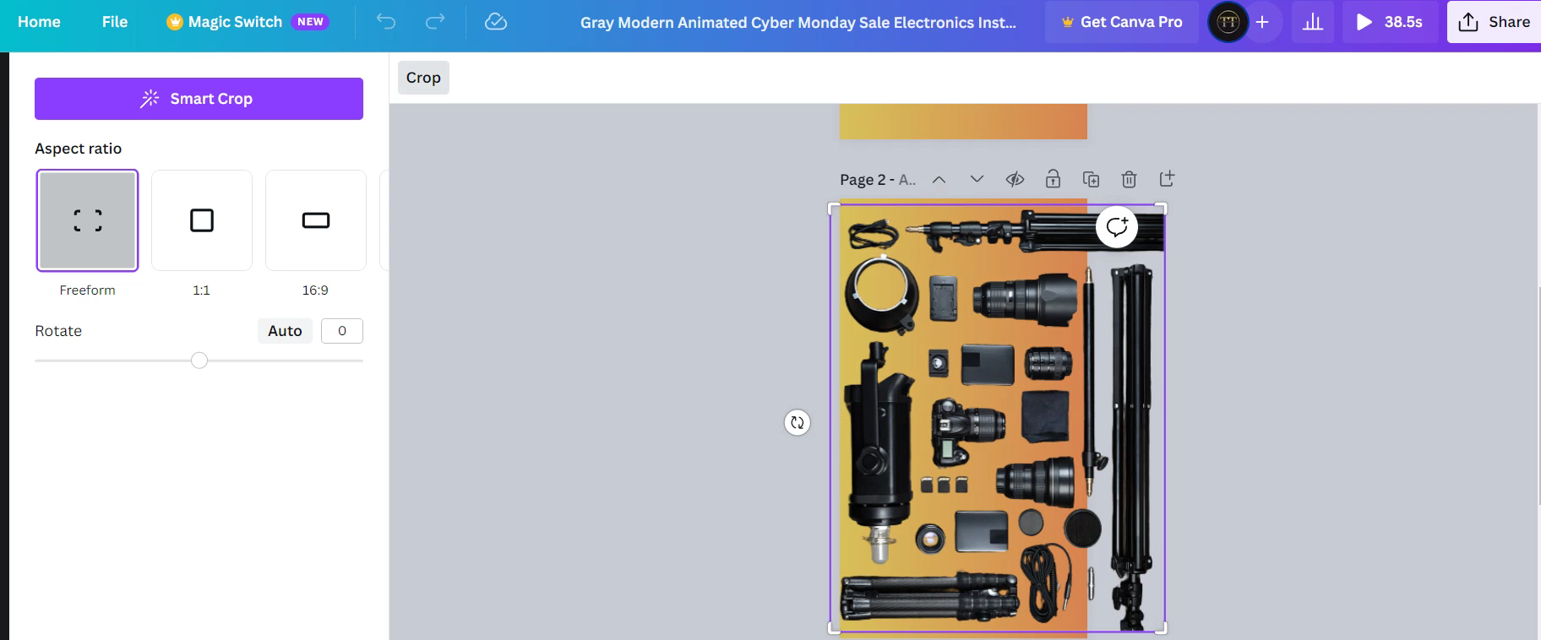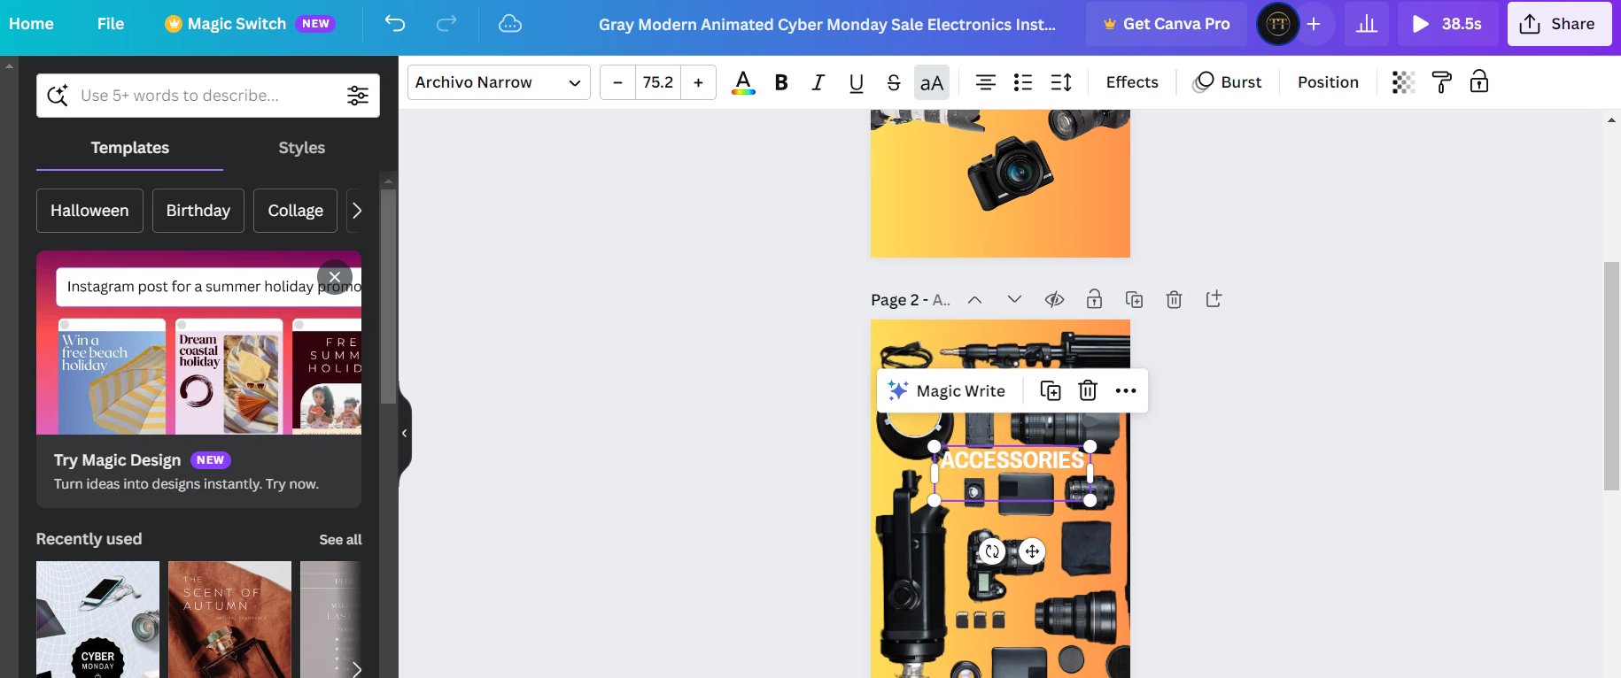

**SECOND SLIDE**

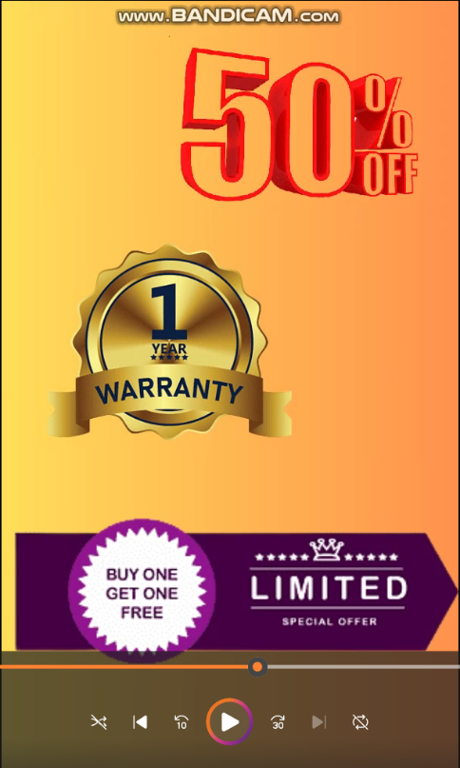

**THIRD SLIDE**

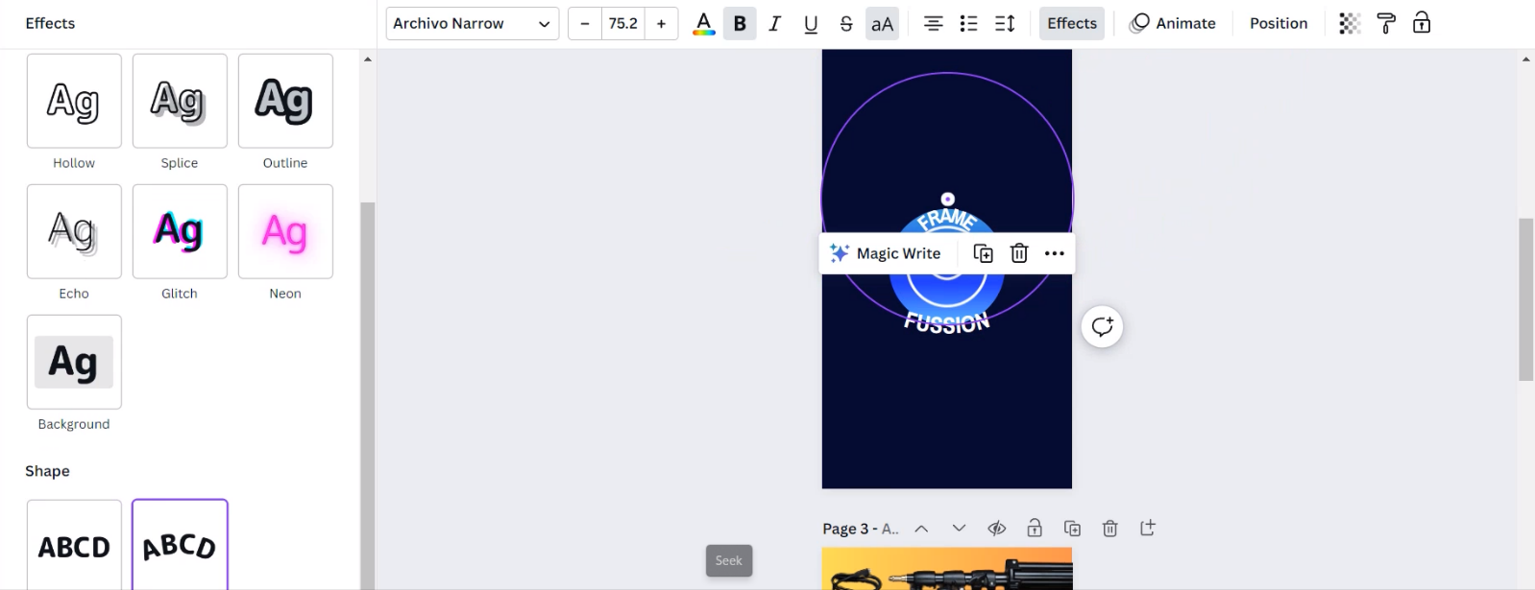**LOGO MAKING USING CANVA(SCREENSHOTS)**



**BRAND LOGO**

INSTAGRAM REEL LINK: <https://www.instagram.com/reel/CysLDlLRTYQ/?igshid=MzRlODBiNWFlZA==>

RECORDED VIDEO LINK: <https://drive.google.com/file/d/19f0n3G_-mN-sIp-DywbsGYpeJmLbWCGP/view?usp=drivesdk>